EGERTON UNIVERSITY


FACULTY OF SCIENCE
COMPUTER SCIENCE DEPARTMENT
COMP 493 – COMPUTER SYSTEMS PROJECT
SPEEDY – LOCAL BIKE HIRE BUSINESS TRACKING TOOL

SUBMITTED BY
PETER BARASA

REGISTRATION NUMBER
S13/04379/21

SUPERVISOR
MR. NJOROGE

COORDINATOR
DR. BOSIRE

Submitted in Partial Fulfillment of the Requirements for the award of BACHELOR OF SCIENCE IN COMPUTER SCIENCE in the Department of Computer Science, EGERTON UNIVERSITY.

JANUARY 2026

DECLARATION
I, Peter Barasa hereby declare that this Local Bike Hire Tracking Tool Project report submitted to the Department of Computer Science, Egerton University, in partial fulfillment of the requirements for the award of the degree of Bachelor of Science in Computer Science, is my original work.
To the best of my knowledge, this project has not been submitted to any other institution or university for any academic award. All sources of information and ideas used in this project have been duly acknowledged.
I take full responsibility for the authenticity of this work and certify that any assistance received in its preparation has been properly acknowledged.

Name: …………………………………………………………………………….
Registration Number: …………………………………………………………….
Signature: ………………………………………………………………………...
Date: ……………………………………………………………………………...
Certified by Supervisor
Name of Supervisor: ……………………………………………………………..
Signature: ………………………………………………………………………...
Date: ……………………………………………………………………………...

ACKNOWLEDGMENTS
This project, "SPEEDY - Local Bike Hire Business Tracking Tool," could not have happened without the support and help of the following individuals.
First and foremost, I want to express my sincere appreciation to both of my supervisors, Mr. Njoroge, for the support, encouragement, constructive criticism, and motivation throughout the duration of the project. The unique skills, passion, and dedication that my supervisors have provided were instrumental in shaping the project's final product.
I also want to thank my Project Coordinator, Dr. Bosire, for his guidance, project coordination, and valuable input that allowed the project to be done according to the academic expectations and guidelines of the Department.
I am grateful for the Department of Computer Science, Faculty of Science at Egerton University for providing students with an excellent place to learn, a place to receive the technical knowledge they need and a place to obtain the technical resources necessary for completing this project.
I want to acknowledge my fellow students, classmates, and friends for the encouragement they provided and the numerous discussions we shared that helped keep me motivated to finish this project.
Finally, a special thank you to my entire family for their unwavering support and encouragement as I completed my education. I would not have achieved my goals without the trust and faith they had in my abilities.
To everyone who has helped to make this project a success in any way, I appreciate the contributions you made.

ABSTRACT
The bicycle-hire shops located near college campuses are largely dependent on paper systems for recording the renting of their bicycles, tracking customers' sessions, and managing billing. Paper systems are cumbersome, mistake-prone, and can result in lost revenue due to a variety of reasons, including poor record management. Therefore, a need exists for an easy-to-use and reliable digital system for small bicycle hire companies located around campus.
The SPEEDY cloud-based Local Bicycle Hire Business Tracking Tool, was developed to help the bicycle hire shops around campus keep track of their rental business accurately. This bike hire software includes secure user authentication, the ability to manage bicycles and their customers, session tracking, and automated billing. It was developed using Java and Spring Boot for back-end processing, Thymeleaf, HTML, Tailwind, and JavaScript for the front-end interface, a relational database back-end via JDBC for data storage, and JSON Web Token (JWT) for secure session management.
Through ongoing system testing, SPEEDY has proven to increase record accuracy by decreasing the number of errors made by users, improve operational efficiency for campus-based bicycle hire shops, and allow cloud technologies to be used to create solutions for real world problems for small local businesses.

TABLE OF CONTENTS
Contents
DECLARATION 2
ACKNOWLEDGMENTS 4
ABSTRACT 6
TABLE OF CONTENTS 7
LIST OF FIGURES 8
LIST OF TABLES 9
LIST OF ABBREVIATIONS/ACRONYMS 10
CHAPTER ONE: INTRODUCTION 12
Background of the Study 12
Problem Statement 13
Objectives of the Study 14
General Objective 14
1.3.2 Specific Objectives 14
Research Questions 14
Scope of the Study 15
Significance of the Study 16
Organization of the Report 17
CHAPTER TWO: LITERATURE REVIEW 18
2.1 Introduction 18
2.2 Established Bike Rental Systems 18
2.3 Related Technologies 19
2.4 Limitations of Existing Systems 20
2.5 Research Gap 21
CHAPTER THREE: SYSTEM ANALYSIS 22
3.1 Existing System Analysis 22
CHAPTER FOUR: SYSTEM DESIGN 24
4.1 System Architecture 24
Frontend Layer 24
Backend Layer 24
Database Layer 25
System Architecture Diagram 26
4.2 Use Case Diagram 26
4.3 Use Case Descriptions 28
4.4 Table Design 28
4.5 System Flowcharts 30
4.5.1 Rental Process Flowchart 30
4.5.2 Payment Process Flowchart 30
4.6 Security Design 31
CHAPTER FIVE: SYSTEM IMPLEMENTATION 33
4.7 Onboarding 34
5.3 Summary 45
CHAPTER SIX: SYSTEM TESTING AND EVALUATION 46
Testing Strategy 46
6.1 Unit Testing 46
6.2 Integration Testing 47
6.1.3 Manual Testing 48
6.2 Test Cases 50
6.3 Results and Discussions 51
CHAPTER SEVEN: CONCLUSION AND RECOMMENDATIONS 52
7.1 Conclusion 52
7.2 System Limitations 53
7.3 Recommendations for Future Work 53
REFERENCES 55
APPENDICES 57
A.1 Logging into the System 57
Step A-2: Registering a New Bike 59
A.3 Bike Rental (Checkout). 60
A.4 Returning Bike and Generating Invoice 60
Appendix B Source Code 63
APPENDIX C: SYSTEM INSTALLATION GUIDE 64
C.1 Required Software for SPEEDY System Setup 64
C.2 Running the System Locally 64
C.3 Establishing a Database 65

LIST OF FIGURES
Figure 1 Tech Stack Used 27
Figure 2 System Architecture Diagram 28
Figure 3 Use Case Diagram 29
Figure 4 Table Design 31
Figure 5 Rental Process Flowchart 32
Figure 6 Payment Process Flowchart 33
Figure 7 Operator Login Page 36
Figure 8 Successful Store Operator Registration 36
Figure 9 Default Dashboard 37
Figure 10 Updating Shop Details 38
Figure 11 Dashboard After a Successful Shop Details Update 39
Figure 12 Bike Management 40
Figure 13 Sample Registered Bike 41
Figure 14 Session Creation 42
Figure 15 Successful Session Creation 42
Figure 16 Real Time Session Monitoring 43
Figure 17 Integrated Development Environment (IDE) 44
Figure 18 Tech Stack and How to Run Locally 45
Figure 19 Codebase 45
Figure 20 Folder Structure 46
Figure 21 Unit Testing Module 49
Figure 22 Frontend-Backend Integration 50
Figure 23 Manual Testing For Session Stopping 51
Figure 24 Billing and Analytics 64
Figure 25 Folder Structure 65
Figure 26 Database Setup 68

LIST OF ABBREVIATIONS/ACRONYMS
SSH – Secure Shell
JDK – Java Development Kit
SQL – Structured Query Language
RDBMS – Relational Database Management System
STK – Sim Toolkit
RPM – Rate Per Minute
JSON – JavaScript Object Notation
HTML – Hypertext Markup Language
API – Application Programming Interface
CSS – Cascading Styles Sheet
AWS – Amazon Web Services
ML – Machine Learning
JWT – JSON Web Token

CHAPTER ONE: INTRODUCTION

Background of the Study
The increasing demand for bike rental services in recent years has been attributed to the expanding student population and their demand for accessible, reliable, and reasonably priced transportation on and around campus. Consequently, the growth of the student population and the need for rapid movement both within and around the campus have resulted in a large number of small bike rental operations emerging. Bike rental shops are critical components of local businesses and support the needs of students for daily transportation.
As such, many rental bike operations still rely on traditional means of processing operations, such as written records, verbal agreements, and paper invoices to manage bike rentals, customer data, and billing procedures. The reliance on manual data processing methods is often associated with inefficient processes and opportunities for error, including lost records and inaccurate time tracking and incorrect bill amounts. These challenges can make it difficult for bike rental owners to effectively manage daily operations, track multiple bikes at once and keep accurate records for tax and business purposes.
As technology has continued to evolve, digital solutions will provide effective methods to eliminate many of these challenges. Web-based systems will automate record tracking, provide more accurate recordkeeping and improve overall operational efficiency by providing centralized data storage locations, secure login authorization methods, and automated systems to manage billable sessions and billing methods for bike rental operations. The goal of this project is to demonstrate how both owners and customers can greatly enhance the management of bicycle rental operations through the use of digital technology.

Problem Statement
Universities have many local bike rental businesses around campus. Most of these businesses use manual processes to record rentals, collect customer information, and bill customers for their bike rentals. Using manual processes can lead to errors such as incorrect billing, lost records, and difficulty tracking how long a bike has been rented. The biggest problem for bike rental businesses is that during peak rental hours, many customers will come into the store at once and rent bikes at the same time. This creates a challenge for business owners to track their daily operations and ensure accountability for their employees while maximizing revenues.
On the customer side, the lack of a simple, affordable, and localized digital tracking system leads to inefficiencies, disputes between customers and rental operators, and poor service delivery. Without the ability to effectively manage the bike rental process with digital tools, the businesses that rely on manual systems are unable to operate effectively and cannot scale their business in a sustainable manner. This issue is indicative of the need for a dedicated digital solution that can help campus-based bike rental businesses meet the operational requirements of their business and customers.

Objectives of the Study

General Objective
The overall purpose of this research is to create an online-based management system for managing the operation and monitoring of bicycle rental companies near university campuses.

1.3.2 Specific Objectives
- To Create a secure (authentication) system that allows access only to those who are authorized
- Track the duration of each bike rental in real-time
- Create and maintain billing records automatically
- Generate reports to assist owners of bicycle rental facilities in making informed decisions.

Research Questions
- The objective of this project is to identify the appropriate methods for implementing an automated bike hire system for businesses located on universities and colleges within a region utilizing a cloud-based infrastructure.
- Secondly, identifying effective methods for maintaining data integrity and accountability through secure management of user sessions and access to the automated system.

Scope of the Study
The goal of this study is to develop and implement an easy-to-use, cloud-based bicycle rental tracking system for small-scale, community-based bicycle rental services operating on university campuses. The purpose of this system is to assist local community bicycle rental businesses to effectively manage their daily cycle rental operations by digitally recording each time a bicycle is rented out and returned, calculating the duration and total rental payment, and keeping and storing basic historical records related to cycle rentals.
The design of this system is based on a lightweight, easy-to-use interface with the capability to operate without an internet connection when there is limited and/or unreliable internet service available. The intended use of this system is to provide local bicycle rental businesses with tools that are more suited to their current business operations than the tools offered through complex commercial bicycle rental system options.
This project will not offer functionality associated with a commercial rental system, such as the ability to track bicycles using GPS, integrate payment methods such as mobile money, provide fleet management for large-scale operations, or provide enterprise-level analytical reporting tools. Instead, this project offers to community-based bicycle rental businesses a simple, effective, and affordable solution for managing their rental operations.

Significance of the Study
The results of this study will prove beneficial for various groups of stakeholders. Local bicycle rental business owners will benefit from using a free, easy-to-use digital tool to eliminate errors made during manual data entry; increase the number of times they track the amount of time customers have used their bicycles; decrease errors related to billing; and increase overall productivity.
Additionally, customers will be able to access accurate billing, fewer customer disputes, and quicker bicycle check-in and check-out processes. Additional advantages offered to customers through the use of the system include an increased ability to monitor bicycle rental times and an accurate accounting of their rental charges.
Finally, college students and software developers benefitted by gaining hands-on experience with the development and implementation of cloud-based (but, offline) systems designed specifically to meet real-world bicycle rental challenges. This project also serves as a prime example of how software engineering principles were applied to build a localized solution to meet the needs of small bike rental companies.

Organization of the Report
There are seven chapters in this report. The first chapter introduces the study by providing background information, defining the problem statement, establishing the objectives, providing research questions, defining the scope, and defining the significance of this project. The second chapter discusses existing literature and systems relevant to bike hire systems and related technologies. The third chapter is an analysis of the system. The system is analyzed through requirements specification and feasibility study. The fourth chapter of the report describes the design of the system, including information about its architecture, database and other system models. The fifth chapter examines the implementation of the system, describing the tools and key features of the system. Chapter six examines the testing of the system and evaluates the results. Chapter seven will provide the conclusion to the project, the limitations of the system and the recommendations for future work.

CHAPTER TWO: LITERATURE REVIEW

2.1 Introduction
The existing literature and the systems that have been implemented to manage bike hire, are reviewed in this chapter, including the technology utilized to develop them, their shortcomings, and where they fail to meet the needs of smaller biking businesses located near universities. By understanding these aspects of current bike hire systems, it can better inform the development of a system such as SPEEDY, a cloud-based system specifically designed to accommodate local bike hire businesses with lower volumes around university campuses.

2.2 Established Bike Rental Systems
Historically, bike rental shops kept all records manually via handwritten logs in addition to using spreadsheets to store and manage rental data, customer data, and billing information. These practices, while affordable, created opportunities for inaccuracies, could be labor intensive and could also create conflicts concerning billing disputes (Smith 2018).
Solution to the needs of the industry is offered through new technology. Digital solutions have also become available such as on-line rental platforms, and POS (Point of Sale) systems. These platforms offer automated billing, tracking of activities, and comprehensive reporting (Jones & Patel 2020). For large commercial bike rental operators, they would be very good choices but are generally prohibitively expensive and overly complicated for small, campus-based bike rental business models. In addition, most of these systems also require a constant internet connection and may have poor availability in some areas of a campus.

2.3 Related Technologies
SPEEDY's design is informed by a number of related technologies as listed below.
- Cloud Based Systems: These provide centralized storage and the ability to access from multiple devices while automating tasks such as data entry, therefore, they work well for small businesses with little or no IT support.
- Authentication Systems: Secure user login and authorization is a high priority for protecting customer and rental information.
- Session Management: Managing duration of bike rentals; provides accurate billing and visibility for Bowling Parks. Most systems use JSON Web Tokens (JWT) for lightweight session management techniques.
- Database Systems: Structured storage of bikes, customers, and rentals are supported by relational database systems. Many systems use JDBC or ORM frameworks for seamless integration with the back end.
These technologies provide the foundation for building a lightweight, user-friendly, and offline-capable system suitable for vehicle and bike hire operations.

2.4 Limitations of Existing Systems
Bike rental management systems have made improvements, however, there are still many issues associated with the use of these systems today.
- Cost: Commercial bike rental management solutions are typically subscription-based or require costly hardware to implement.
- Complexity: Due to the fact that many different bike rental management solutions on the market are over-engineered for small businesses, it can be very difficult for operators who do not possess the proper technological skills to use them properly.
- Localization: Most bike rental management solutions have been created for large metropolitan areas and, therefore, offer no solutions that address the specific difficulties of a bike rental management startup that is functionally based on a campus.
- Internet Dependency: Most bike rental management systems require constant Internet service to work properly. As a result, if a bike rental service is located in the outskirts of a city or in an area with poor internet coverage, those systems will not work well.
Due to these limitations, there is now a greater need for a simpler, more affordable, and more localized alternative system that can function well in the campus environment.

2.5 Research Gap
The findings of the review and existing equipment used demonstrates that there are no affordable, simple, and offline solutions to assist small local bike rental companies in improving their operational efficiency through the use of technology. Other digital solutions offer more functionality than required, cost more than small businesses can afford, or require a continual internet connection.
In order to fill this void and support small bicycle rental operators, SPEEDY has developed a cloud-based, easily accessible, lightweight and user-friendly platform. This platform will allow small bicycle rental business owners to maintain rental records digitally, determine rentals fees automatically, and keep historical records even when the business is operating in poorly connected environments. This research provides a practical solution for small local bicycle rental businesses that operate near university or college campuses.

CHAPTER THREE: SYSTEM ANALYSIS

3.1 Existing System Analysis
Most university campus neighborhoods currently use manual (paper-based) record keeping to operate the majority of their local bicycle rental businesses. Bicycle rental owners perform the following support functions manually; record the times of bike rentals (checkout/in) and billing information via a paper log or formulated on a simple spreadsheet. The advantages of using these traditional, manual advertising methods are their low costs and low technological knowledge requirements. However, these traditional methods can also present incorrect record-keeping issues and inefficiencies.
Problems Faced With Current Methods Are;
- Accurate Timekeeping
Because owners record the time of check-ins and check-outs for customers on paper, there is a higher chance of making entry errors due to busy periods when multiple bicycles are checked out. Therefore, the rental period could be recorded incorrectly and lead to confusion on the customer's part when it comes to billing disputes.

- Time-Consuming Billing Process
Bicycle rental owners are required to manually calculate the rental duration for each customer and bill them accordingly, which is very time-consuming and creates the potential of billing errors.
- Limited Storage/Record Keeping
Due to the nature of the operation, many owners will not maintain an electronic record of their rental history. Historically, maintaining recognizable rental records has been challenging, and if an owner loses or misplaces their paper logs, they risk losing all their past rental data. This creates barriers for analysis of past rental trends and performance over time.
Because of these limitations, there is an urgent need for a lightweight cloud-based solution for automating all rental management processes including tracking, invoicing and storing information in a way that is easily accessible and usable by college/university personnel operating bicycle rental programs on their campuses.

CHAPTER FOUR: SYSTEM DESIGN

4.1 System Architecture
The SPEEDY platform utilizes a three-part architecture - the frontend, the backend, and the database - that makes it flexible, easy to develop new features, and easily expand as more customers use the service.

Frontend Layer
The frontend provides bike rental businesses as well as their customers with a web-based application. It enables users to register for rentals, check rental bikes in/out of service, and send STK push payment requests. The application is light and offers offline access via USSD commands. The overall user experience was prioritized to make it easy to use.

Backend Layer
The backend component of SPEEDY is built in Java with Spring Boot. It is responsible for the business logic, managing users, authenticating them, and managing their sessions. JWTs (JSON Web Tokens) were chosen for securing authentication and enabling role-based access control for users. Rental information, available bikes and users' data can all be accessed using GraphQL endpoints from the backend service, while payment requests sent via STK push prompt, are processed in the backend service.

Database Layer
PostgreSQL serves the system's relational database. This is to store the basic persistent data of the system, including the users, bikes, rental sessions, and collateral data. To connect to the database, the system connects via JDBC. This provides the ability to ensure reliable and fast communications between the database and the client (user). The schema of the database provides for two different rates for each bike, tracking the rental duration, and tracking payments for analytics purposes.
System Stack Diagram
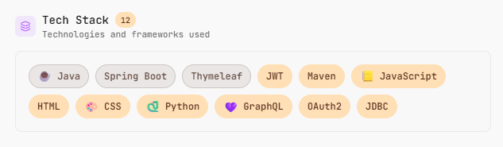
Figure 1 Tech Stack Used

System Architecture Diagram
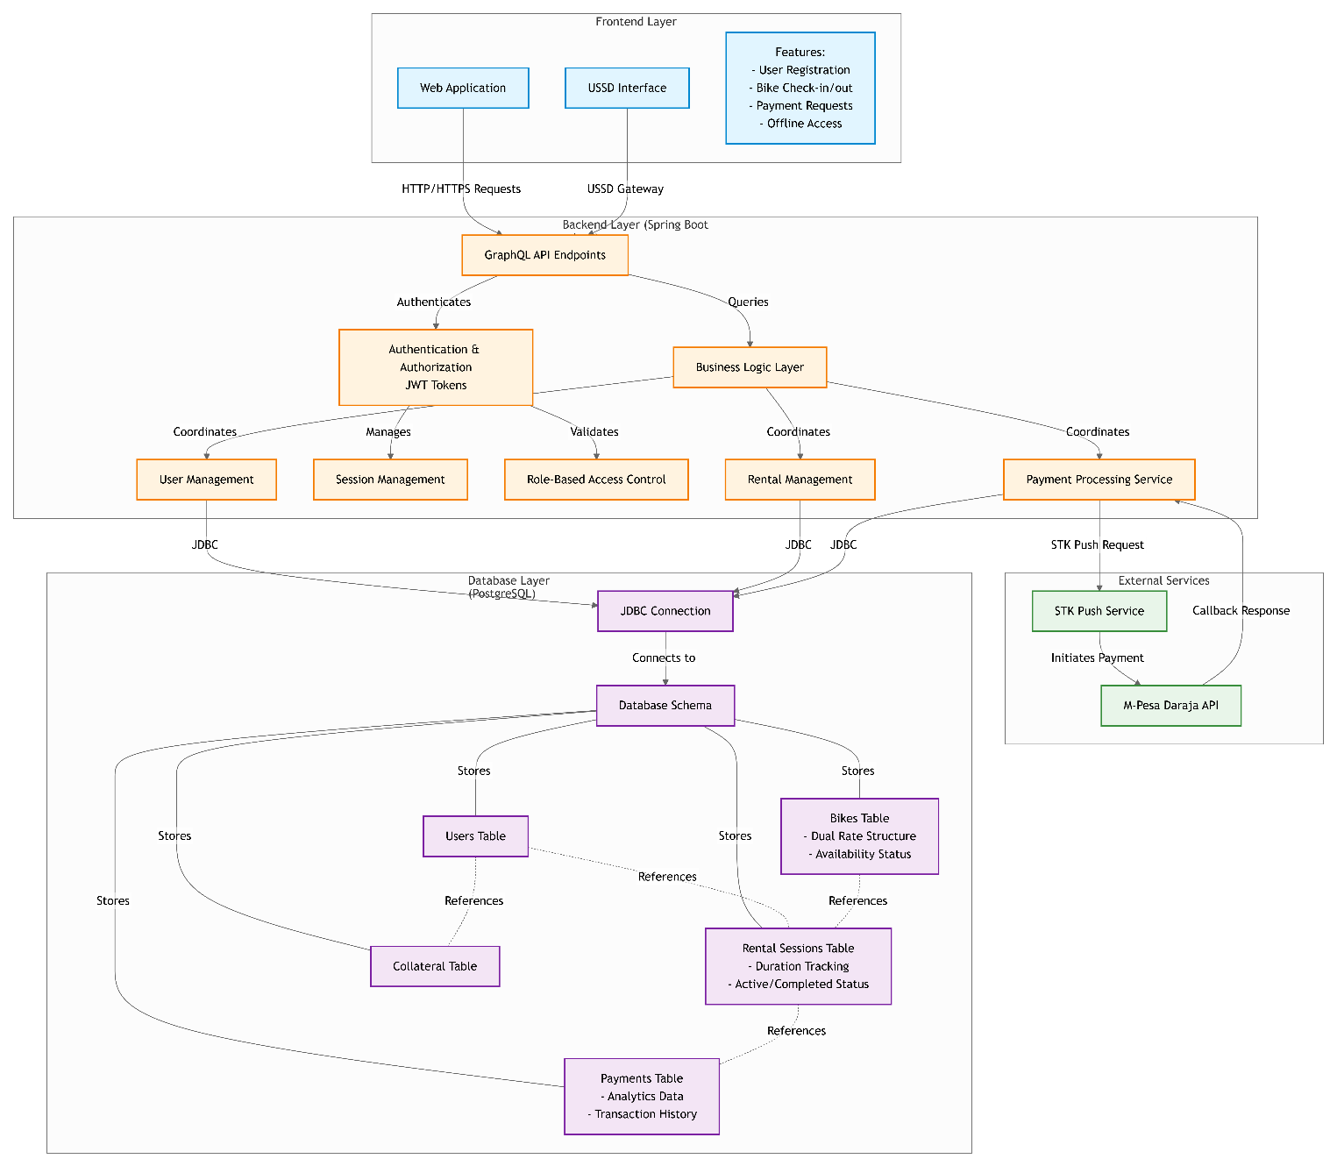
Figure 2 System Architecture Diagram

4.2 Use Case Diagram
Within SPEEDY, there are three main users:
Bike Rental Operator - Registers customers, assigns bicycles, records bicycle rental sessions and tracks payments.
Customer - Provides the information needed to rent a bicycle and has the ability to make an STK push payment.
System Administration (Optional) - Administers users and their accounts and system settings.
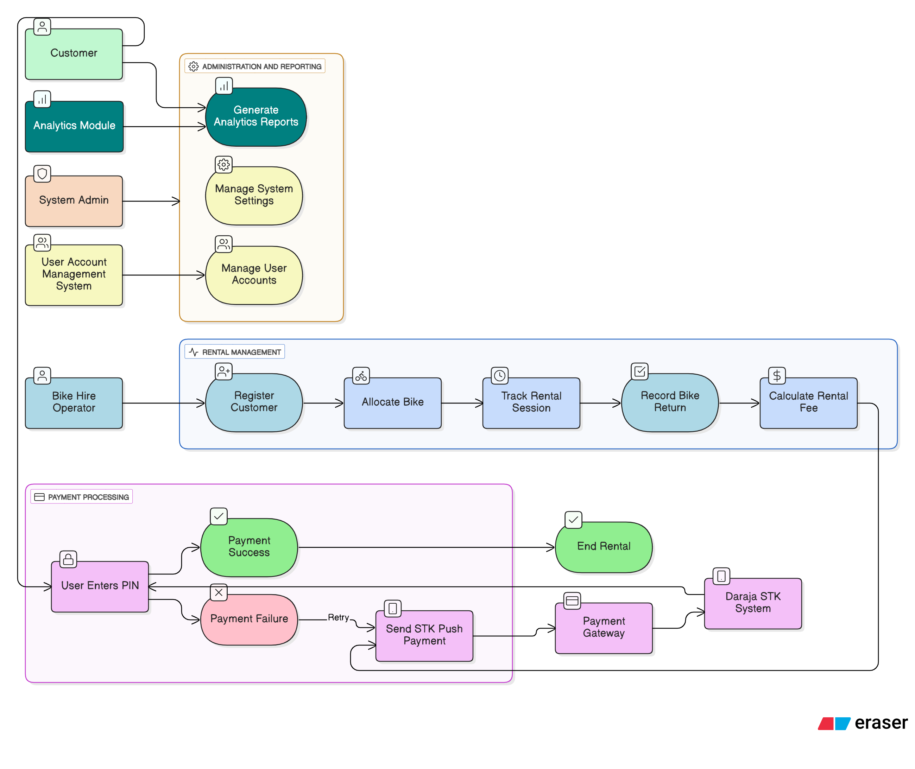
Figure 3 Use Case Diagram

4.3 Use Case Descriptions
Table 1 Use Case Descriptions
Use Case Name | Actor | Description
Register Customer | Bike Hire Operator | Collects customer information, collateral, and optional picture.
Allocate Bike | Bike Hire Operator | Assigns a bike to the customer and starts rental timer.
Track Rental Session | System | Tracks the duration of rental in real-time.
Return Bike | Bike Hire Operator | Stops the timer and records return time.
Calculate Rental Fee | System | Calculates amount based on bike rate and rental duration.
STK Push Payment | Bike Hire Operator | Sends payment request to customer’s phone who confirms completion.
Generate Analytics | Bike Hire Operator | Displays historical rentals, revenue, and usage trends.

4.4 Table Design
The database schema is designed to support bike rentals, user management, and payments. Key tables include:
- USER stores customers, with flexible extra attributes in addinfo (JSON).
- SHOP represents bike rental shops, each owned by a user, and also supports extensible metadata.
- BIKE belongs to a shop and defines pricing via rpm (rate per minute).
- SESSION is the core transaction table, linking a user, shop, and bike for a rental period using start and stop times.
- SESSION_REPORT captures the financial and transactional outcome of a session, including duration, charges, transaction codes, and descriptions.
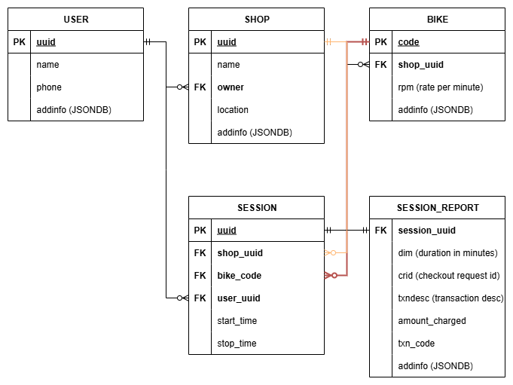
Figure 4 Table Design

4.5 System Flowcharts

4.5.1 Rental Process Flowchart
- Customer provides details and collateral
- Bike is allocated by operator
- Start time is recorded and timer begins
- Bike is returned; stop timer
- Calculate rental amount based on bike rates and duration
- Send STK push request to customer phone
- Complete payment
- Record transaction for analytics

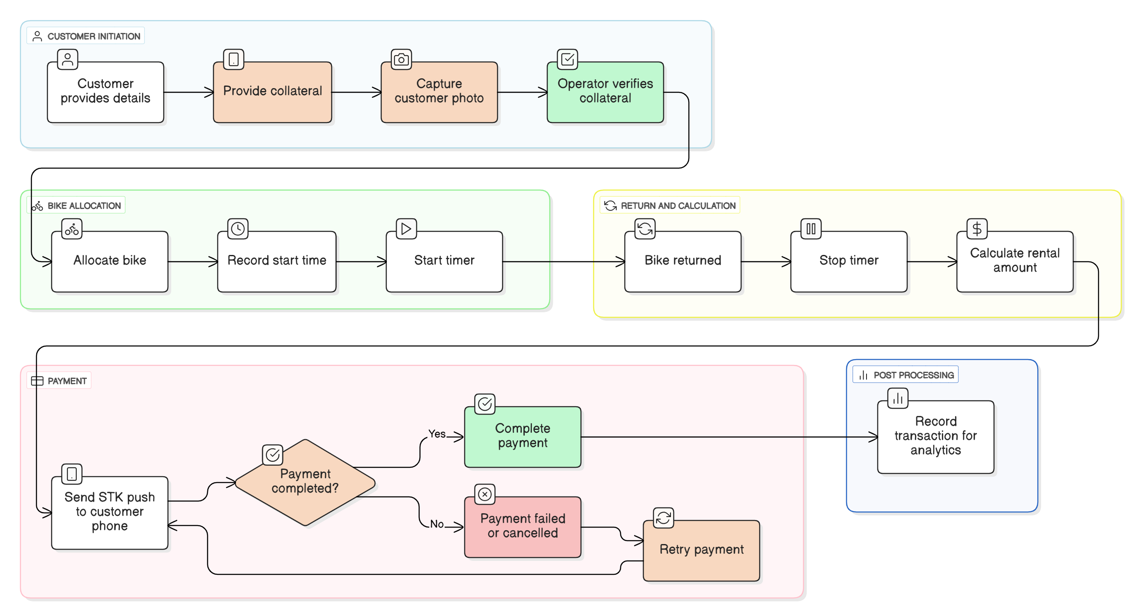
Figure 5 Rental Process Flowchart

4.5.2 Payment Process Flowchart
- Rental amount calculated by backend
- STK push request sent via payment gateway API
- Customer completes payment on phone
- Payment status confirmed in database
- Operator receives confirmation and finalizes checkout
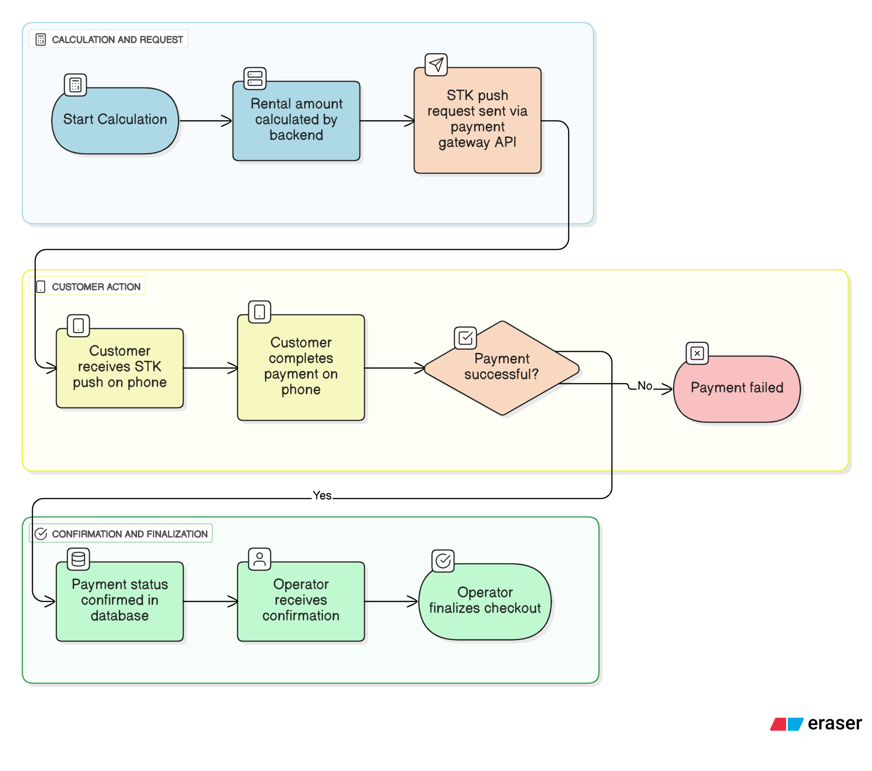
Figure 6 Payment Process Flowchart

4.6 Security Design
Multiple layers of security are in place to protect the application.
- Authentication & Authorization: Users authenticate with JWT tokens, while the role-based access control ensures that only those users who have the appropriate role can perform sensitive operations. In the system, nearly all the actions are performed by an authorized store operator.

- Data Validation: Bike codes are system generated to ensure consistency. All other inputs provided by customers are validated in order to safeguard the database against any potential SQL injection or other data inconsistencies.

- Offline & USSD Security: While USSD security uses telecom network controls instead of end-to-end encryption, its speed and accessibility have made it quite popular. Since sessions are managed via the operator and have a short lifespan (less than one hour), the risk of session interception is lowered considerably. With that said, since USSD is reliant on a user's phone number as the only way to identify users, USSD is susceptible to SIM swapping, social engineering attacks (e.g., phishing attacks), and weak third-party systems. To combat this vulnerability, providers place limits on the number of PINs entered, sometimes limit the volume or frequency of USSD transactions, and implement encryption and fraud detection mechanisms.

- Secure Payment Handling: STK push requests are sent directly to the user’s mobile device through secure binary encrypted API endpoints, meaning that no sensitive card or account information is retained by the system.

CHAPTER FIVE: SYSTEM IMPLEMENTATION
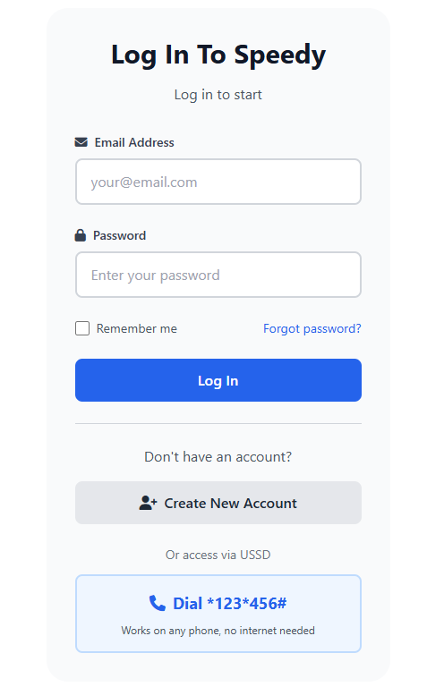
The purpose of this chapter is to explain how SPEEDY was developed as a cloud-based application. In addition, this chapter will provide an overview of the requirements for the system, as outlined in Chapter 4; the methods used to build the application; the tools and technologies put to use during development; and the development of key functionalities such as customer registration, bike assignment to users, rental history tracking, automatic billing, and STK push payment integration.

Figure 7 Operator Login Page

4.7 Onboarding
The Store Operator registers through the web interface. Upon completion they can be allowed to log in to their account using the created credentials.
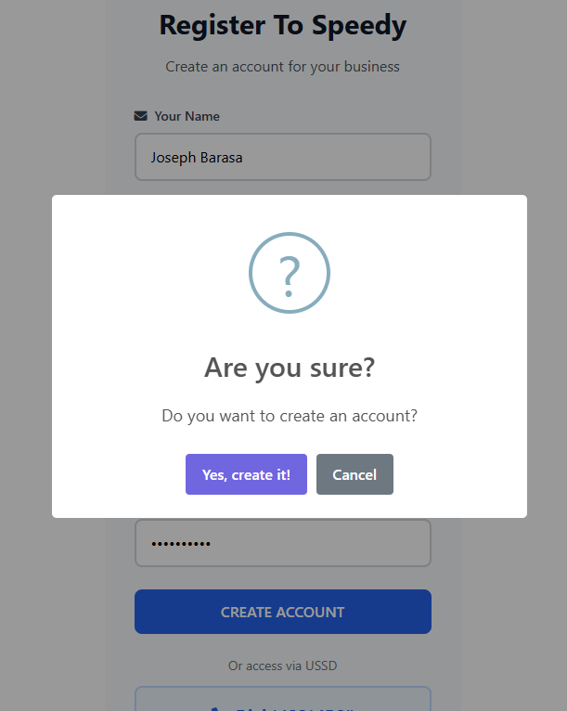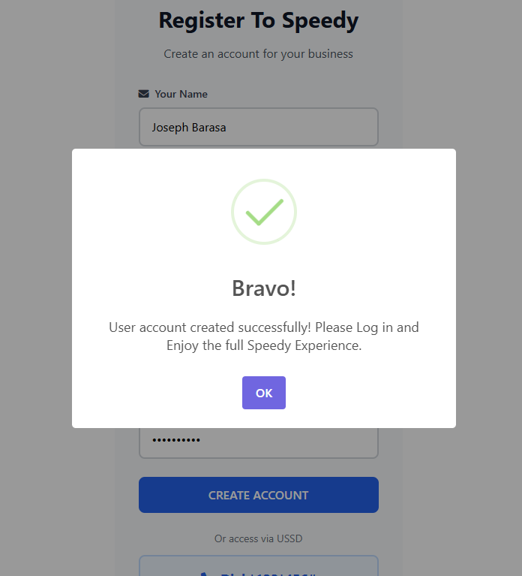
Figure 8 Successful Store Operator Registration

The Default Dashboard: The user is prompted to update the Shop/Store Details to access all the features.
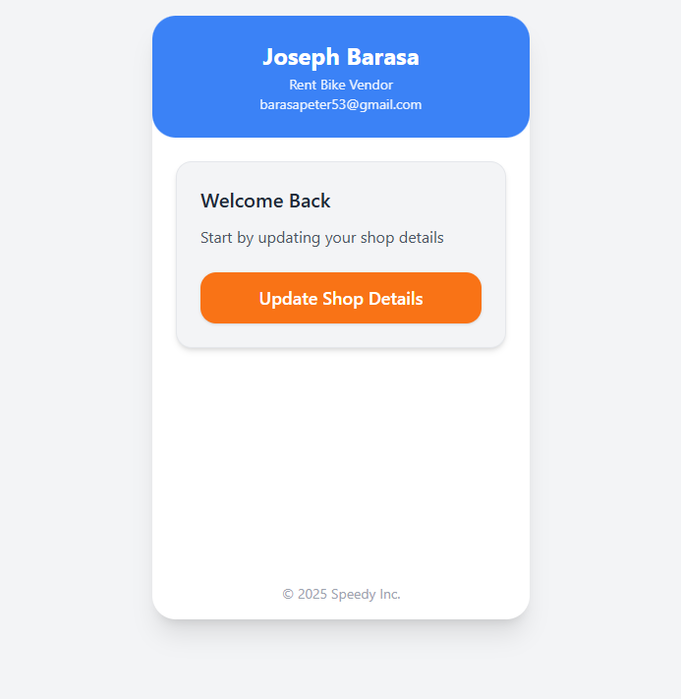

Figure 9 Default Dashboard

Updating Store Details: The system prompts for basic store details to be used in reports.
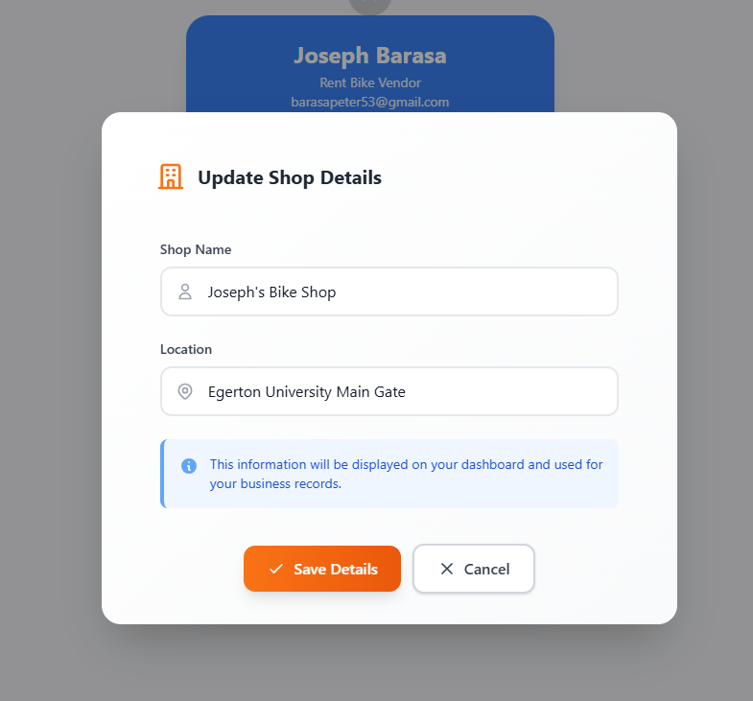
Figure 10 Updating Shop Details

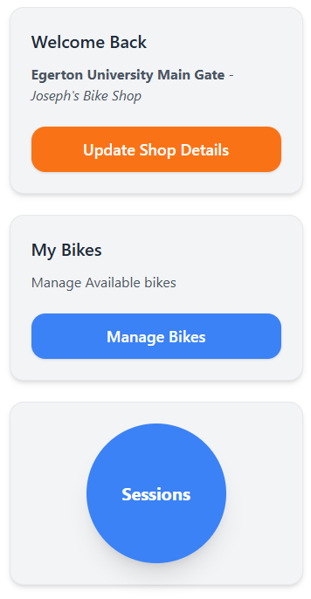
Dashboard After a Successful Shop Update: The basic functionalities are now available; adding bikes and monitoring sessions:
Figure 11 Dashboard After a Successful Shop Details Update

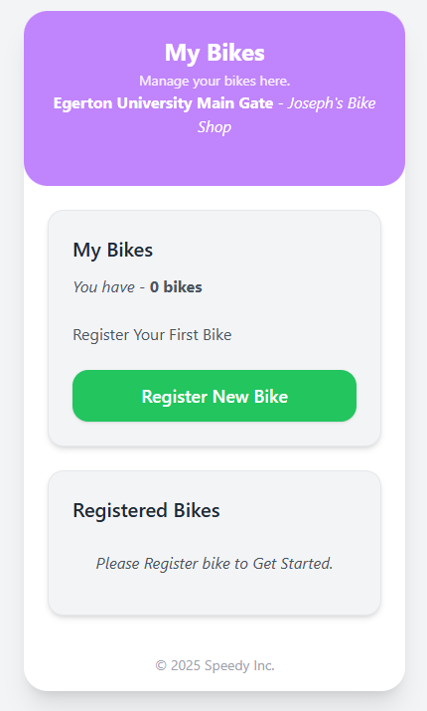
Manage Bikes: The operator can add new bikes, delete some, etc. Existing bikes can be edited too.
Figure 12 Bike Management

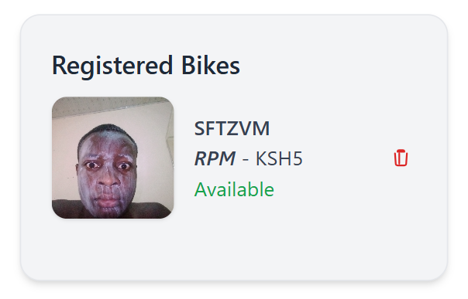
Figure 13 Sample Registered Bike

This is a sample registered bike. The operator can add its picture and RPM (Rate Per Minute). RPM refers to the charge per minute. A unique six-character code is generated to represent the bike. This code is printed on a sticker and embedded on the bike for reference and tracking purposes.

Creating a New Session: The operator picks a bike. He/she scans or reads the bike code from the sticker and enters it along with other information:
Figure 14 Session Creation
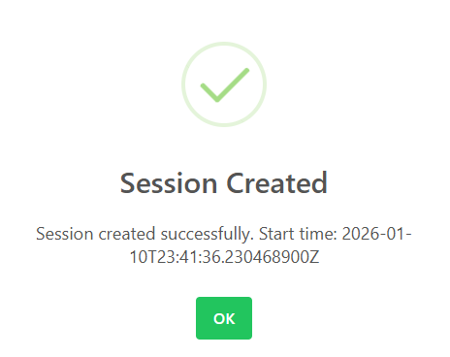
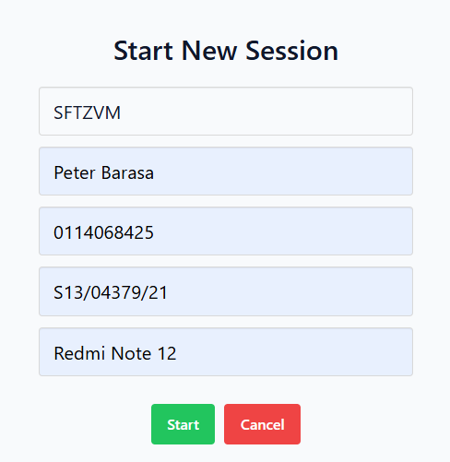
Figure 15 Successful Session Creation
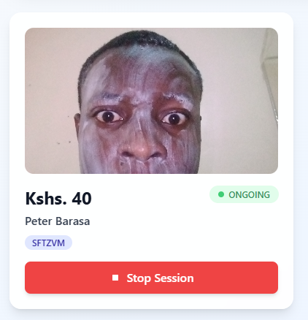
Ongoing Session: The ongoing session is charged based on the RPM of the bike selected:
Figure 16 Real Time Session Monitoring

5.2 Development Tools and Technologies
Java - All backend services, business rules and the database integrations were built in Java
Spring Boot - This framework helps speed up the development of backend code (serving/handling dependencies) and creating REST and GraphQL endpoints and enabling the use of JWT for secured user authentication.
Thymeleaf - This server-side template engine renders dynamic HTML in the browser side of the application.
JavaScript - JavaScript is used to provide interactivity on the client side, for example each Rental has a timer (counting down until it can no longer be rented) or providing triggers for STK Push notifications.
HTML and CSS - Markup and Style sheet for a responsive user-friendly user interface
Tailwind CSS - Utilized to expedite the style of the pages using a responsive design pattern.
Font Awesome - Provides a library of icons to apply to buttons, workflow steps and feature icons.
Python (Utility scripts) - Used for back-end utilities, reporting and analytics, payment handling and shell scripting.
GraphQL - GraphQL provides a flexible way to run queries against the Rental, Bike or User data.
OAuth2 - This is an optional method of authentication that allows for integration with external services.
JDBC - JDBC provides reliable connections to a PostgreSQL Relational Database.
Maven - Maven provides dependency management and build automation for Java/Spring Boot components.
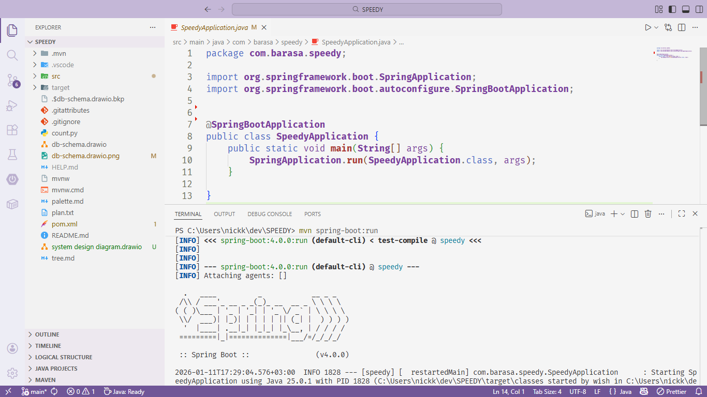
Figure 17 Integrated Development Environment (IDE)

Tech Stack and Running it Locally – Screenshots
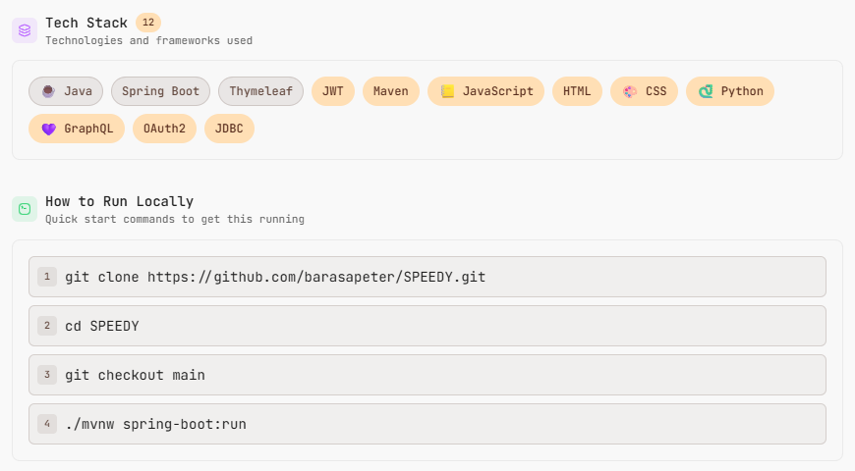
Figure 18 Tech Stack and How to Run Locally

Source Directory Tree – Codebase
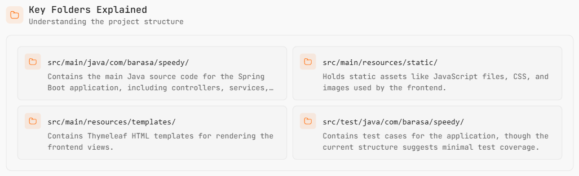
Figure 19 Codebase

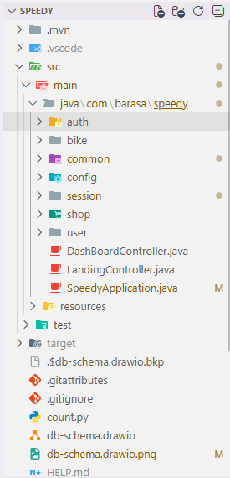
Figure 20 Folder Structure

5.3 Summary
The system design has become active through SPEEDY with actual use happening now. The technical combination of technologies in this example was Java, Spring Boot, Thymeleaf, PostgreSQL and contemporary front-end technologies. This combination of technologies gives the user a lightweight, secure and convenient platform for operating local based bike hire business. We have successfully implemented all primary modules (such as Customer registration, Bike allocation, Rental Tracking, Automated Billing, STK Push Payment, and Offline Support) and they are functional in an operational capacity.

CHAPTER SIX: SYSTEM TESTING AND EVALUATION

Testing Strategy
The overall goal of the system testing of SPEEDY was to demonstrate that the system meets both the functional and non-functional requirements and to ensure the reliable operation of the system in a typical campus bike hire environment. The testing process focused on confirmation of the accuracy, usability, performance, and security of the system. The following approaches to system testing were taken:

6.1 Unit Testing
The test of each system component (or module) was a Unit test. Unit testing verifies that each module works properly. The major units tested include the login authentication, bike allocation logic, rental duration calculation, and calculation of billing. Each of these unit tests ensured that, for a given input, the module will produce the same output as specified, before integrating the module with other modules.
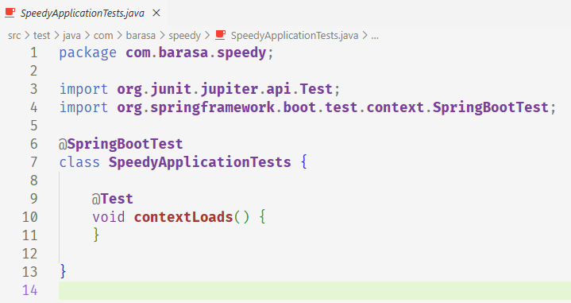
Figure 21 Unit Testing Module

6.2 Integration Testing
Integration testing was performed to confirm the proper operation of all system modules working together. Integration testing consisted of testing the interaction between the Front-End (Thymeleaf templates), Back-End services (Spring Boot controllers and services), Database (PostgreSQL via JDBC), and Third-Party Services (STK Push Payment APIs). Integration testing ensures that data flows properly through the layers of the system without any errors.
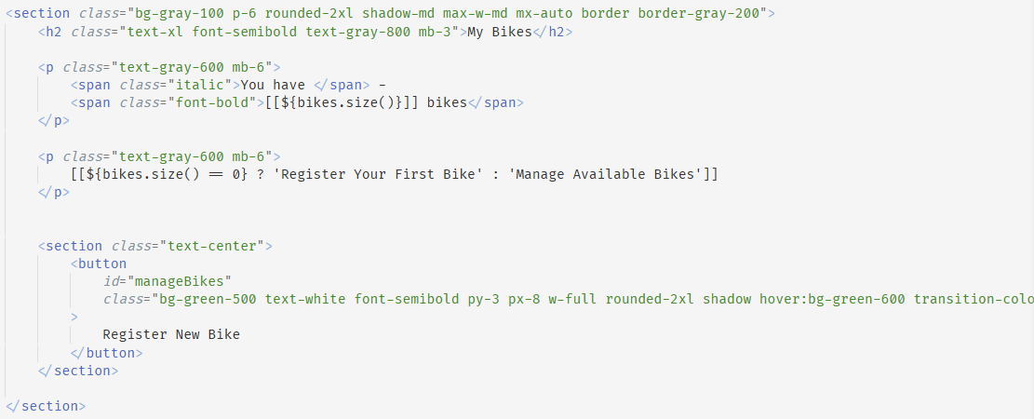
Figure 22 Frontend-Backend Integration

6.1.3 Manual Testing
In a local bicycle rental store, an operator ran through various common actions that would happen when customers were using the system manually (e.g., registering bike rentals, assigning a bike, recording bike rental transactions, returning the bike, receiving payment). With the use of manual testing, user-friendly issues for non-technical users were identified. In addition, offline and USSD testing scenarios were used to confirm that the system was still usable even with limited connectivity.

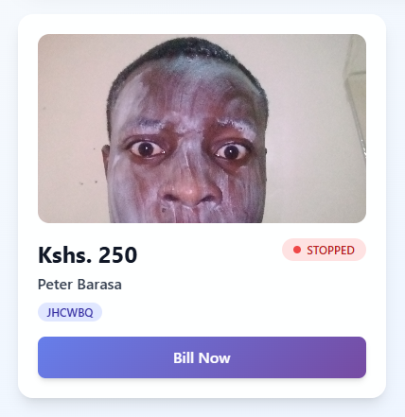
Figure 23 Manual Testing For Session Stopping

6.2 Test Cases
Table 2 Test Cases
Test Case | Input | Expected Output | Result
User Login | Valid username and password | User successfully logged into the system | Pass
User Login | Invalid credentials | Access denied with error message | Pass
Register Customer | Name, phone number, collateral details | Customer record saved successfully | Pass
Allocate Bike | Available bike selected | Bike assigned and rental timer started | Pass
Return Bike | Valid return action | Timer stopped and duration calculated | Pass
Billing Calculation | Rental duration and bike rate | Correct rental amount generated | Pass
STK Push Payment | Customer phone number and amount | Payment request sent and confirmed | Pass
Record Storage | Completed rental session | Rental saved for analytics | Pass

6.3 Results and Discussions
The outcomes derived from TESTING validate that SPEEDY has achieved the requirements established for the campaign. With respect to user authentication and session management, both were very dependable and achieved their objectives. The TESTING sessions confirmed that OPERATORS would benefit from user-friendly processes and require no technical experience. Offline/USSD INTERACTIONS confirmed that the app was appropriate for the USE on CAMPUS where INSURGENCY was AWFUL.

Generally, the TESTING verified that SPEEDY Effectively DECREASED MANUAL RECORD KEEPING, LOWERED BILLING ERRORS, and INCREASED OPERATIONAL EFFICIENCY for local operators renting bikes off the CAMPUS. Hence, the SPEEDY App achieved its goals and will I am confident that it can be IMPLEMENTED.

CHAPTER SEVEN: CONCLUSION AND RECOMMENDATIONS

7.1 Conclusion
The objective of this project was to design and develop SPEEDY, a cloud-based bicycle rental management system for small local bicycle rental businesses operating around university campuses. SPEEDY has successfully addressed the difficulties associated with manual record keeping by automating many of the tasks involved with customer registration, bike assignments, rental session tracking, billing and payment processing through STK push integration.

By using modern technologies - Java, Spring Boot, Thymeleaf, JWT and PostgreSQL, SPEEDY has demonstrated that cloud-based application software can be used to improve efficiency, reduce human errors and increase the level of service provided by small businesses in a timely manner. The results of testing and evaluation have confirmed that SPEEDY successfully achieves all the goals outlined in the project description; SPEEDY is an easy to use, reliable, efficient solution that works in both online and offline mode, and SPEEDY represents a low-cost digital solution that makes managing bicycle rental businesses much easier.

7.2 System Limitations
Even though it was successfully implemented, the system has a number of limitations:
It has no dedicated Mobile App. It uses a web interface and USSD, instead.
It only provides limited analytical and reporting functionality – there are no advanced data visualizations and no predictive analytics.
External vendor services, needed to perform STK push payments, may experience service outages or delays.
In the current release, GPS tracking and real-time bike location tracking is not available.

7.3 Recommendations for Future Work
It is recommended that additional system functionality and usability improvements be implemented in future development.
1. Design and develop a Mobile Application to increase accessibility and improve user experience for Operators.
2. Implement advanced analytics/reporting dashboards to provide improved insights into business performance.
3. Incorporate additional payment options, (e.g., Mobile Wallets), into the System including cash reconciliation features.
4. Add GPS-based bike tracking to increase security and improve overall fleet management.
5. Increase Offline Capability of System to allow more complex operations to be performed in the absence of the Internet.

REFERENCES
- Sommerville, I. (2016). Software Engineering (10th ed.). Pearson Education.
- Pressman, R. S., & Maxim, B. R. (2019). Software Engineering: A Practitioner’s Approach (9th ed.). McGraw-Hill Education.
- Gamma, E., Helm, R., Johnson, R., & Vlissides, J. (1994). Design Patterns: Elements of Reusable Object-Oriented Software. Addison-Wesley.
- Pautasso, C., Varga, E., & Zaremba, M. (2020). GraphQL: A data query language for APIs. IEEE Software, 37(1), 26–33.
- Fielding, R. T. (2000). Architectural styles and the design of network-based software architectures. Doctoral dissertation, University of California.
- Oracle Corporation. (2023). Java Platform, Standard Edition Documentation.
- Walls, C. (2022). Spring Boot in Action (2nd ed.). Manning Publications.
- Richards, M., & Ford, N. (2020). Fundamentals of Software Architecture. O’Reilly Media.
- PostgreSQL Global Development Group. (2023). PostgreSQL Documentation.
- OWASP Foundation. (2022). OWASP Top 10 Web Application Security Risks.
- Kent, B., & Fowler, M. (2003). Test Driven Development: By Example. Addison-Wesley.
- Fowler, M. (2018). Refactoring: Improving the Design of Existing Code (2nd ed.). Addison-Wesley.
- W3C. (2022). HTML5 Specification.
- Mozilla Developer Network. (2023). JavaScript Documentation.
- Tailwind Labs. (2023). Tailwind CSS Documentation.
- Font Awesome. (2023). Icon Library Documentation.
- OAuth Working Group. (2019). OAuth 2.0 Authorization Framework.
- Newman, S. (2021). Building Microservices (2nd ed.). O’Reilly Media.

APPENDICES
Appendix A - A Beginners Guide to Using the SPEEDY System
This guide will provide step-by-step instructions on using the SPEEDY System on a Bike Hire System designed for operators who may have limited technical knowledge. Our goal with this User Manual is to make it as easy as possible for Bike Hire Operators to implement, so they can use it with their existing equipment and customers.

A.1 Logging into the System
Open the SPEEDY application via an established Internet browser (Chrome, Firefox, etc.), or by using the USSD/QWERTY codes.
To log in, enter your registered phone number or email, and your password into the fields provided on the login page.
Click the 'Log In' button to access your system dashboard.
If you forgot your password, click on 'Forgot Password' and follow the email instructions to reset it. If you're a new user and want to create an account, click 'Create Account' and fill in the required information.

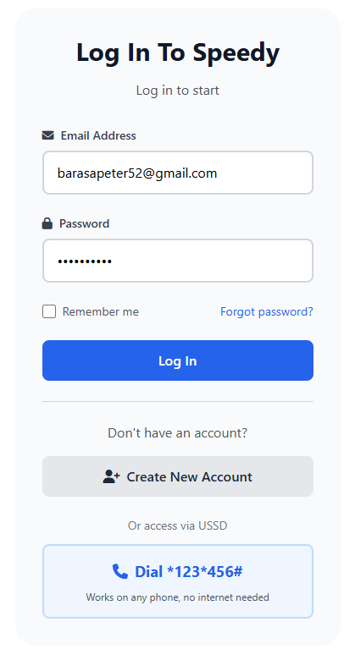
Log In Using Username and Password. If no account, create one using the “Create New Account” button. If forgotten password, then reset.
Table 3 Login Page

Step A-2: Registering a New Bike
- Access the Bike Management tab on the Dashboard.
- Select 'Add New Bike'.
- Fill out the fields that contain the following data on the new bike:
- Name or Identifier
- Category or Type
- Per Min or Per Hour Charging Rate
- Press 'Save' to save this new bike's record.
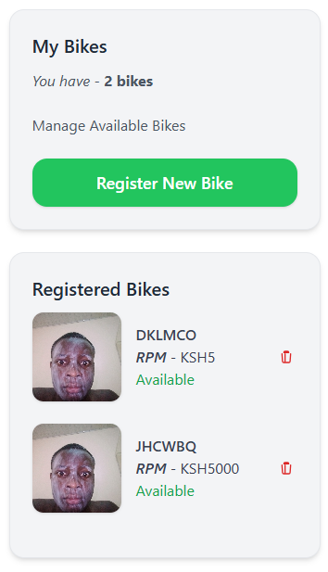
- The bike will then be available to be assigned to customers.

Table 4 Bike Listings

A.3 Bike Rental (Checkout).
- Click on New Rental from dashboard.
- Enter customer details: Name, Registration number, Phone number, Optional photo, Collateral details, Collateral name (e.g. Cell Phone)., Approximate value of collateral.
- Select an available bike from the list.
- Click Start Rental, which records the time of check-out and begins the bike rental timer

A.4 Returning Bike and Generating Invoice
When a Customer Returns the Rental Bike:
1. Go to Active Rentals and Find and Select the Active Rental.
2. Click “End” to Complete the customer’s Rental

After clicking “Stop Session”, the system will automatically:
• Stop the Active Rental Timer
• Determine how long the Customer rented the Bike for (Rental Duration)
• Calculate the amount owed to the Company for the length of the Rental (Rental Rate)
• Send an STK push request to the Customer’s mobile number requesting payment.
Once the customer pays, the system will automatically complete the checkout process and create a Record of the transaction.
Table 5 Stop Session Interface
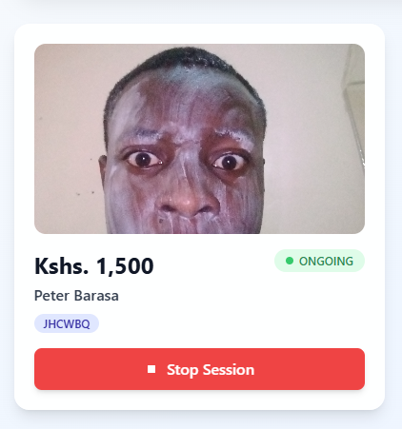
A.5 Rental Records and Analytics
Use the Reports / Analytics tab to view historical rental records, total revenue, and summaries of bike usage. Use the information you obtain to help you make informed business decisions about your bike rental service.
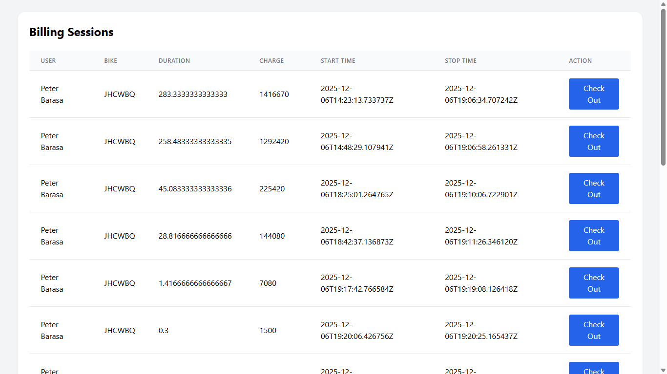
Figure 24 Billing and Analytics

Appendix B Source Code
In this appendix, the entire source code for the SPEEDY project has been made available on the project's repository. The source code is structured in such a way that it is easy to navigate:
- Backend components built with the Java Spring Boot framework to provide business logic and access APIs
- Front-end components include Thymeleaf templates, HTML pages, CSS files, and JavaScript files.
- Database components include a PostgreSQL schema and JDBC database access.
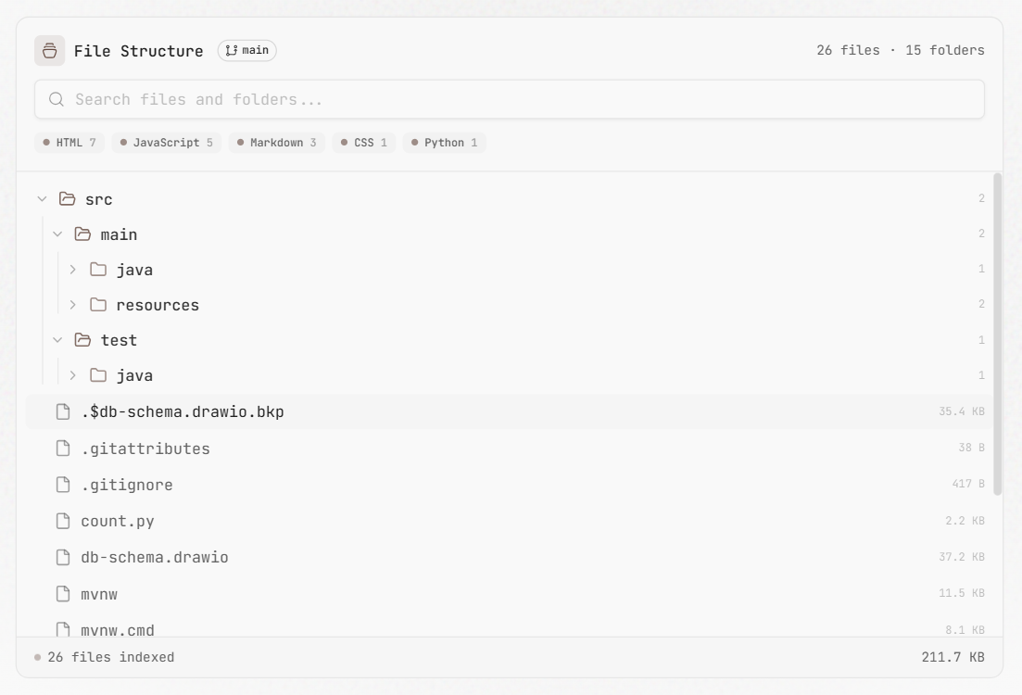
Figure 25 Folder Structure
The SPEEDY source code reflects the principles of software engineering best practices such as modular design, concern separation, and secure authentication of users via JWT.

APPENDIX C: SYSTEM INSTALLATION GUIDE
Here are the guidelines on how to set up and utilize the SPEEDY System on your own computer.

C.1 Required Software for SPEEDY System Setup
- Java Development Kit (Version 17 or higher)

- Maven Build Tool/Application

- Postgres SQL Database Server (RDBMs)

- A web connection (not required until after SPEEDY is set up).

C.2 Running the System Locally

Clone the repository
git clone https://github.com/barasapeter/SPEEDY.git

Navigate to the project directory
cd SPEEDY

Checkout the Main Branch
git checkout main

Run the Application
./mvnw spring-boot:run

Access System at
http://localhost:8080

C.3 Establishing a Database
- Install PostgreSQL on the target server to create a new database called speedy.

- Configure the application's database credentials in the application's application.properties file.

- Start using the application, and automatically create the database tables.

- You can verify your newly created tables using any PostgreSQL client tool.

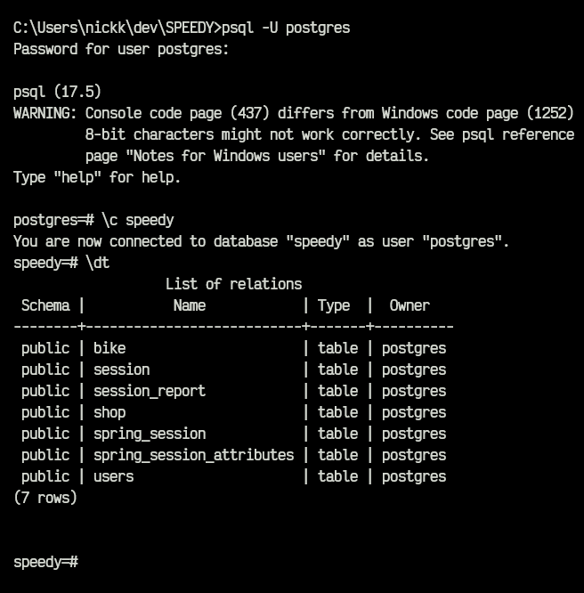
Figure 26 Database Setup

